University of Mary Department of Education Lesson Plan (with ECE adjustments)
SOLAR
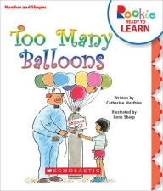
Age Level: Preschool
Subject(s) Area: Language Arts, Mathematics, and Art
Materials Needed:
- Book: “Too Many Balloons” by Catherine Matthias
- Paper (plain/blank)
- Pencils
- Markers/Crayons (possibly water color)

Standards:
PD.1.2 Engage in a variety of activities that require fine motor skills (e.g., art projects, manipulative toys, dressing)
ART.4.1 Use a variety of media and techniques to create art, including a variety of two-dimensional and three dimensional processes.
LL.1.5 Understand that illustrations and pictures convey meaning.
MTH.1.1 Demonstrate an understanding that numbers are always in the same order: 1, 2, 3 (stable order counting principle), and that the order when counting objects does not affect the total (order irrelevance counting principle).

Objectives:
Students will listen and follow along with the book.
Students will be able to identify shapes that are used in art (images in books).
Students will be able to predict the sequence of numbers up to 11.
Students will be able to create their own balloon and animal drawing.

Learning Activities:
- The teacher will introduce the book. Explain that authors write the book and illustrators draw or create pictures for the books.
  - Tell the students to look at the colors and shapes that the illustrator uses.
- As a class we will read through the book “Too Many Balloons.”
  - Ask questions as you read to keep the students engaged and following along.
- Then we will discuss what number of balloons would come next.
  - Count and show them 1, 2, 3, 4… 10. What comes next?
  - Explain that they are going to make 11 balloons.
  - Show poster (below)
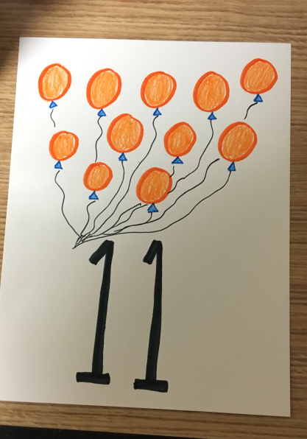

- The teacher will introduce art project. Each student is going to be an illustrator that is creating the next page in the book.
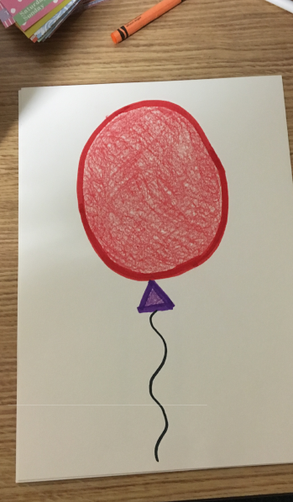
  - Creating 11th page so draw 11 balloons. Show students the picture of the balloon and ask them to find shapes in the balloon.

    - Circle
    - Triangle
  - Have students draw their own animal (any animal they want).
    - Prompt them with animals they saw in the book or animals they see at the zoo. Favorite animal?
    - Have students look for the shapes they use to draw the animals.
- Then the children will be able to create and draw their own animal on their piece of paper.
  - Have paper folded in half so that you can have students draw the balloons on the TOP of the page and their animal on the bottom.
- The class will share some of their pictures and animals that they came up with.
- To end the lesson, explain to students again that they were illustrators that used shapes to create the pictures for the book.
Reflective Questions:
-What shapes do you see here?
-What shapes do you see in the balloon?
-She bought 7, 8, 9, then 10 balloons. What would come next?
- What animals do you see at the zoo?
- How many balloons do you think she will buy next? (predict)

Vocabulary Words:
-Zoo
-Circles and Triangles
-Animals (apes, crocodiles, flamingos, pigeons, etc.)
-Straight and rounded lines

Assessment:
The main form of assessment will be observation. The teacher will look to see that the students are participating and engaged in the activity. When the students complete their art project (page for the book) the teacher can see if they used and recognized triangles and circles to draw the balloons. The teacher could also use questioning/probing to see if they student is able to identify shapes in the book.

Reflection:
Overall I would say this lesson went okay. I think I had a few too many things planned and therefore was overwhelmed and missed different opportunities while I was teaching. One thing I realized right away was that when I asked the students to recognize the shapes (circle and triangle) I should have demonstrated how to draw them. We could have talked about a triangle being 3 straight lines and a circle being a rounded line which would have tied in another art concept. I also think I was rushing through the lesson because I was so worried about hitting each point that I missed some things. For example when reading the book to the students I should have explained in the beginning that an illustrator creates pictures for the books and then told the students to look for shapes in the book and pay close attention to the pictures. I didn’t really introduce this idea of becoming the author and illustrator until after I had finished reading so I think it would have been more effective if I mentioned in before I began reading. Mrs. Bassingthwaite also offered a really helpful suggestion where I could have told them to look for shapes and then ask them on different pages to point out the shapes. I could’ve then tied into the fact that different artists use different shapes like Kandinsky and circles. I think if I were to teach this lesson again I would either bring or pull up and image/painting of an artist and ask the students to point out the shapes. I think this would really drive the point that artists and illustrators use shapes to create images. I would say that the math component of this lesson went really well. It seemed to be very effective in having the students count to 11. Several of them practiced their counting skills many times throughout this activity and also had to realize how many more balloons they needed to draw. When the students that finished earlier completed their work I asked them to go and read or look at books on the carpet. I should have asked them again to try and identify the shapes the author used (it would have been another teaching opportunity). I ended the lesson by having the students share the art pictures they had created with the class. I explained that they had all been wonderful illustrators and did a great job of creating another page of the book. I think I should have reviewed the shapes that they saw in the book and what shapes were used to create their balloons.
This lesson taught me a lot about teaching. I realized that I need to slow down and take advantage of every teaching moment rather that rushing through and trying to complete the project. I put a lot of different concepts into this lesson and I think I should have focused on certain things more like drawing the different shapes and the lines used to do so. I feel like the kids really enjoyed the lesson, but I definitely could improve it and make some changes if I taught this lesson again.

