Classroom Philosophy

Emily Fox
EDU 301: Classroom Management
Dr. Lamb

Throughout the semester I was exposed to various different classroom management styles. When you see all of the various strategies you see that they are effective for that teacher, but what about your future classroom? I tend to be more soft spoken and quiet so I often wondered if I could see myself using different techniques. You begin thinking about your future classroom and what type of management style you will lose. The only thing I knew before entering this class was that I was going to be the teacher who yells. Not because it hadn’t happened to me in school, but because it just was not my personality. This class, although it was only a semester and we met twice a week,, I learned a lot and have put thought into what I want my future classroom to look like and the management style I would like to use. You can obviously have as many plans as you would like and you still have to adjust and integrate your plans and ideas to best fit the class you have.
This semester was also my first practicum experience so I should say that my plan for my future classroom is very flexible because I cannot decide which grade I would like to teach. I have always thought kindergarten or first grade, but for my practicum experience I was in a fifth grade classroom and I absolutely loved it. Classroom management styles will be very different between a kindergarten and fifth grade classroom. Kindergarteners are young and do not have the same background knowledge about what school expectations are. As a kindergarten teacher you are laying the foundation for how students act in school for many of the grades to follow. Fifth graders have more of an understanding of what is expected in the school environment. The fifth grade students need to be held accountable for their actions and choices, but you are not introducing new concepts they haven’t heard before.
In The Classroom Management Book by Wong and Wong it was written that the three characteristics that a person must contain to be an effective teacher are classroom management, mastery of the lessons and content, and positive expectations (2014). These are all very important to becoming an effective teach because you have to understand the content and lessons you are teaching so you are able to individualize and adapt the lesson to best fit each student in your classroom. You have to have effective classroom management because that allows you to teach and keep your composure in the classroom. A teacher also needs to have positive expectations. You need to believe in your students and know they are able to achieve and learn. A teacher has to be willing to work with various other people including parents, because they know their child better than you know your students so they are a valuable resource to help you engage their child.
No matter the grade, in every classroom you need to start implementing and teaching your procedures, strategies, and expectations on day one. In order to have an effective classroom management you must implement procedures that provide for an organized environment that allows children to learn (Marzano & Pickering, 2003). When you establish procedures the students are able to have a classroom that is predictable and consistent which is very important for students. When the students know what to expect they are much more comfortable. One way I want to teach these procedures is through practicing with students over and over. If I end up teaching in the younger primary grades I would also want to decorate my classroom with visual representations or reminders of the procedures. For example by the door I would want to have a sign saying the expectations of no voice, hands to ourselves, and facing forward. Creating visuals with graphics would be very helpful and effective to teach procedures to my students. I would also want to teach my procedures verbally. Once the students are made aware of the expectations you could model for your students or have several of them model the correct procedure.
One thing I really want to focus on as a teacher is getting to know my students. I think that being able to relate to them and talk to them really shows them that you care. When students feel that they can trust you they are much more likely to work hard because they want to make you proud. Every student is going to be unique and have their own preferred way of learning. I believe it is your responsibility as a teacher to discover with each student how they learn best. In college we have been exposed to various strategies and learned about the different modalities of learning. All of this is very helpful, but only if you are able to apply the strategies and techniques you learned to the students in your classroom. We know that you have to teach to many of the modalities so that your curriculum reaches each student, but you need to know the students in your classroom in order to make any of it possible.
Along with listening to my students I want to start every day on the right foot by greeting them at the door. In this classroom management class we saw several examples of why this seemingly little thing means so much to your students and can have a large impact on the your classroom. In Chapter 26 of The Classroom Management Book they discussed the procedure of having morning meetings (Wong & Wong, 2014). This is something I saw in my practicum classroom and want to integrate into my future classroom. Morning meetings are a great way to organize your classroom and bring everyone together. During a classroom meeting you get the students focused and ready to learn, but you also have time to go over the schedule for the day or upcoming events. It is also a good time to allow students to voice their concerns. In my practicum classroom the teacher had three students share a day. It was an organized way to have everyone share and the students could tell the class and the teacher what they are feeling that day. As a teacher it is really helpful to know and understand your students so having the chance to hear from you students in the morning is very important. In the younger grades, I really liked the idea of having each student give you thumbs up, thumbs down, or sideways, for how they feel that morning. Then you can either ask or talk to the child individually about how they feel that way today. If you understand your students and know how they are feeling you will be able to engage them and help them discover their knowledge much more.
A major factor in getting to know your students is the ability to listen. When you listen to your students you are creating a connection and establishing trust. Along with you being able to listen to them, the students need to be able to listen to one another. In chapter 27 of Wong’s The Classroom Management Book it explained the importance of classroom discussions (2014). Students need to learn and be aware of the appropriate times to listen and speak in the classroom setting. They need to understand how to act respectfully and feel comfortable participating in classroom discussions. When the students feel at ease with sharing their work and opinions with the class it also builds their self-image.
This is another large aspect of my classroom philosophy. I want my students to know that they are capable if they work hard and are determined. I will be there to work with them and try to find strategies and techniques that will work for them. I want my students to have a positive self-image. My students should know that they are all good at something. A lot of times I feel like students whether it be grades or feedback hear, “This isn’t good enough.” This is something that breaks down their self -image and confidence. As a teacher I want to focus on the positives in each of my students. That is not to say that I won’t help them improve in areas they are lacking, but I want to approach it in a positive way where they don’t feel they have disappointed me. In an article titled Is Antagonism Between Students and Teachers Inevitable by Catherine Gobron she wrote about school being difficult for students, but you have to be there for your students. You need to be the motivation and should be a tool or resource that your students can count on to make them feel better about themselves, not worse.
As far as classroom set up I really like the idea of pods of desks. Maybe four pods with roughly five to six students at each. This was the set-up of my fifth grade classroom for practicum. One of the main reasons I liked it was because it allows for collaboration and discussion. Many of the lessons and discussions were completed in their pod groups. The pods changed every two weeks. Having pods already established made organizing the groups for small group work much easier. Small group work is an important component of learning to work with others and share your own opinions. When they are working in groups it is promoting teamwork and is a practical experience for when they are employed in the future (Wong & Wong 2014). As a teacher you need to make sure that you can separate the groups efficiently and quietly, which would be much easier if they pods were already in place. In my practicum classroom they used the pods to have discussions about their daily math and the students were much more likely to come up with the correct answer if they could talk it out with their peers. One aspect I feel will be difficult with this as a teacher, is making sure that everyone is held accountable and doing their job. Each student needs to participate to make small or large group work effective.
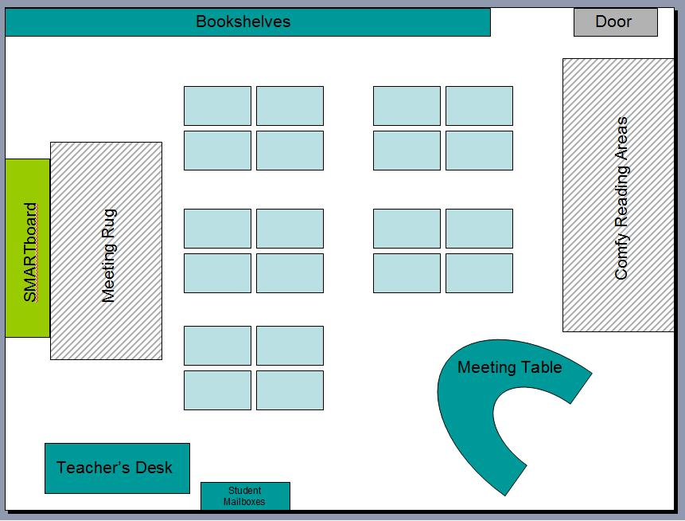
http://therealteachr.blogspot.com/2012/06/classroom-seating-arrangement.html
Along with my pods of desks I also want my classroom to have a large meeting rug where the entire class is able to gather. For activities like Daily 5 I would want my students to sit together for the minilessons at the meeting rug and then they can spread throughout out the classroom to have their individual work time. One thing I noticed and really liked in my practicum classroom was the comfy seating my teacher had placed in his classroom. He had two bean bag chairs and a few pillows around his classroom and the students loved to go and sit in them a read or do their work. You would definitely have to have rules and procedures in place so that the students don’t misuse the privilege of having comfy chairs. For example, in my classroom I would likely have a rule that while I am teaching or lecturing the students would not be able to sit in the chairs or use the pillows and when we meet at the rug in the back no one is allowed to have pillows or the chairs.
In my classroom setup I also want to have stability balls in my classroom. If I had four to six students at each pod of desks, I think I would like to have two stability balls at each table. Having a few stability balls at each table, but not enough for every student in the classroom can teach the students several different lessons. The students will have to share and be able to problem solve when certain students want to use the stability balls. I think these are an important part of the classroom because they help students concentration, which allows them to focus and learn more. Again, from day one you would have to establish procedures and rules for the use of stability balls in your classroom. Students need to be aware that the balls are not to be a distraction or a toy; the stability balls are there as a tool and that is how they should be used. In my practicum classroom they had stability balls and one day one of the students actually threw the ball across the room. As a teacher there would need to be a consequence for the behavior and misuse of the ball and you would want to have the rules and expectations established before any of the actions occurred.
For my classroom philosophy on discipline or consequences I want to implement the principles-based approach (Fay, 2011). In sense this is dealing with discipline in an individual basis because if you establish the rules and expectations you have to follow through with that child. The principles based approach means that there is an established set of rules or expectations, maybe even school-wide. Then if a student makes an infraction or does not follow these rules, the teacher is able to use their discretion to determine what an appropriate form of discipline would be for that student (Fay, 2011). I really like this because along with every student being an individual, various disciplines or consequences will be more meaningful to different students. You want to have consequences that you are able to follow through and complete with your students. It is your responsibility as a teacher to hold each of your students accountable for their actions in the classroom.
When I become a classroom teacher I want to have a positive impact on my student’s lives and education. I have plans about my management style and lessons I want to teach, but at the end of the day it is going to depend on the class I have that year. Each student is important and is capable and willing to learn, I want to be the teacher that helps them recognize it in themselves. I will do my best to always stay positive. I want to point out the good that students are doing rather than always trying to correct them. We all chose to become teachers for different reasons, but many of the reasons likely have to do with the students. The students are the most important component of our classroom so I have thought a lot about my philosophy and management style, but it will likely change once I meet and get to know my students. My classroom management class taught me several effective techniques and strategies that I would like to implement into my future classroom. I have a much clearer and more understood idea of how much goes into creating a classroom that helps your students grow and develop. As a teacher you have to put time and thought into every aspect of your classroom so that it is beneficial to your students. I learned a lot about my classroom philosophy, but I think it will continually change and adapt as a learn more about teaching and my individual students.

References

Fay, Jim (2011). Creating a Love and Logic School Culture. Love and Logic Institute, Inc.: Golden, CO.

Gobron, Catherine (2015). Is Antagonism Between Students and Teachers Inevitable? The Huffington Post, Inc.: New York, NY.

Marzano, R. J. & Pickering, D. J. (2003). Classroom Management that Works: Research –based strategies for every teacher. ASCD Press: Alexandria, VA.

Wong, Harry & Wong, Rosemary (2014). The Classroom Management Book. Harry K. Wong Publications, Inc.: Mountain View, CA.

